Apply DE Louisiana

High School Counselor / Administrator

User Guide

Part 1: Managing Students 1
Pending Recommendation 1
Registrations by Term 4
Students by Term 4
Part 2: Student Notes 5
Part 3: Managing School Personnel 5
Part 4: Managing Your Password 7

Part 1: Managing Students
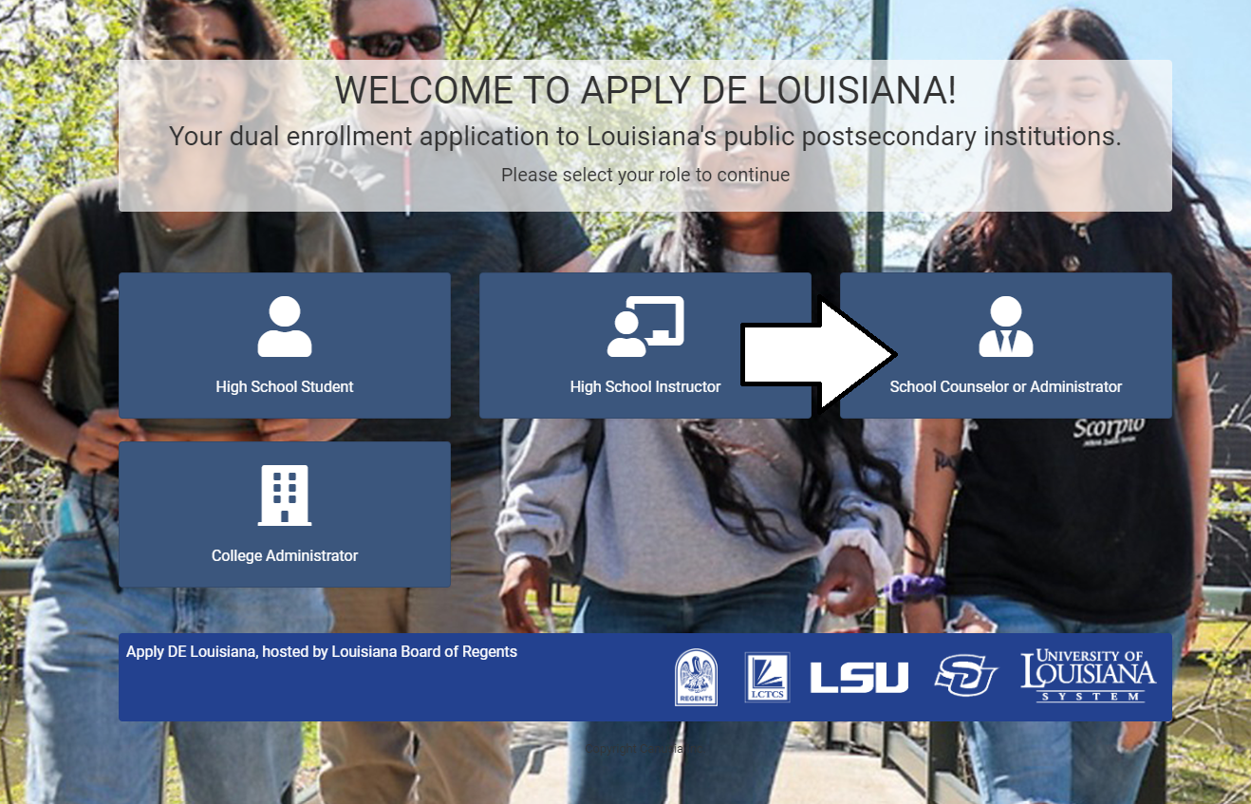
Welcome to Apply DE Louisiana – your portal to managing students’ dual enrollment within Louisiana’s public postsecondary institutions. To get started, navigate to https://applyde.laregents.edu and select the “School Counselor or Administrator” tile.
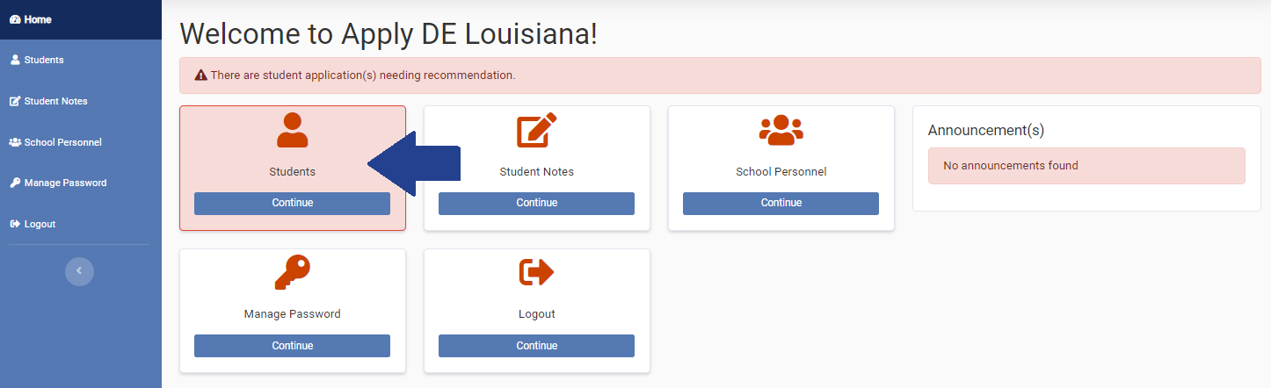
If there are pending applications, there will be a message along the top of the screen indicating recommendations are needed and the “Students” tile will be highlighted on the main Home screen. Click on the “Students” tile or tab in the left sidebar to get started.

Pending Recommendation
You’ll find multiple tabs to help you manage your dual enrollment students. The “Pending Recommendation” tab displays a list of students who have a pending application for dual enrollment. There are two columns displaying per application showing the status of the student agreement and parental consent form. To submit a recommendation, click on the “Submit Rec.” button for a student.
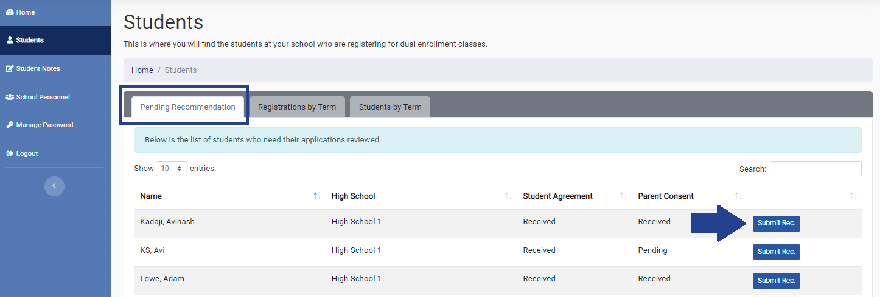
A pop-up window will appear displaying multiple tabs, the default being the recommendation form for the classes the student has applied for. On this tab, you will need to (1) approve or not approve each course selected, (2) choose the student’s GPA, (3) select the grade level they will be when taking the listed courses, and (4) answer whether the student has met the course prerequisites (if any)* and has the permission of the high school to enroll in the listed courses.

You also have the option of uploading a file and/or providing a description of the student’s qualifications or any other information that may be helpful in determining their eligibility. When you are finished, click the “Submit Recommendation” button.

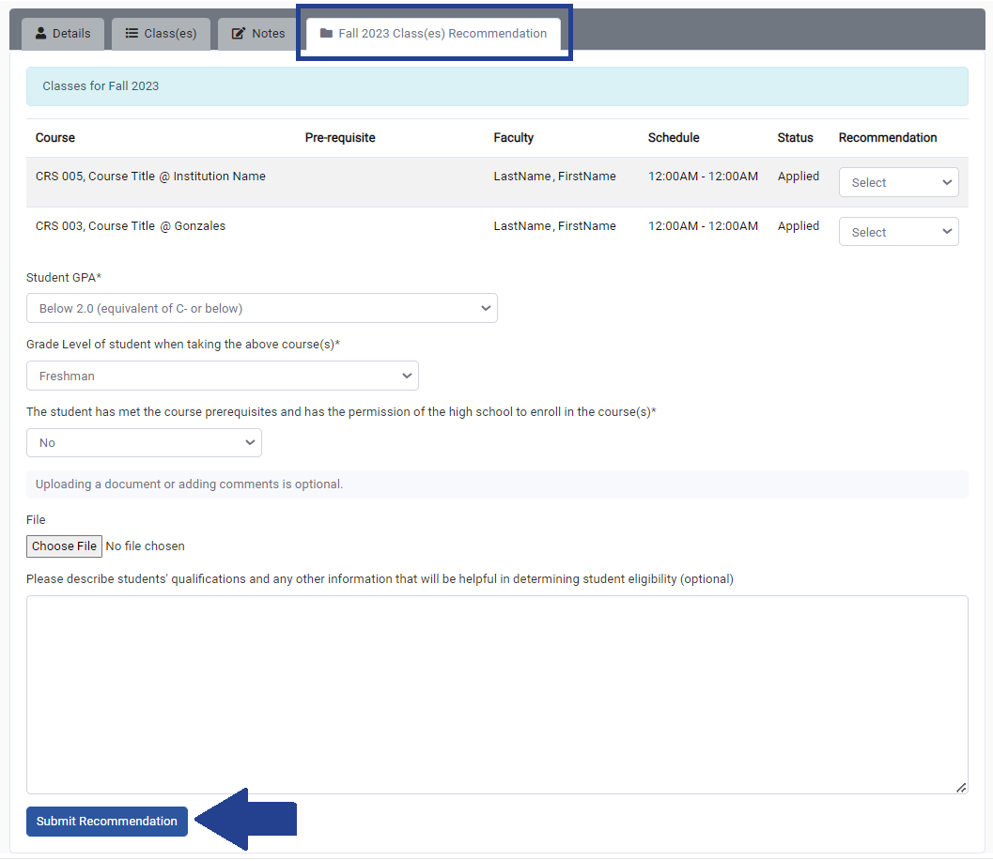
Please note that if you have not selected an “Approve” or “Not Approved” option for all of the listed courses, the recommendations will only be saved as a draft and will not be considered complete.

*If you are not sure if a class has a prerequisite, clicking on the “Class(es)” tab will provide you with this information.
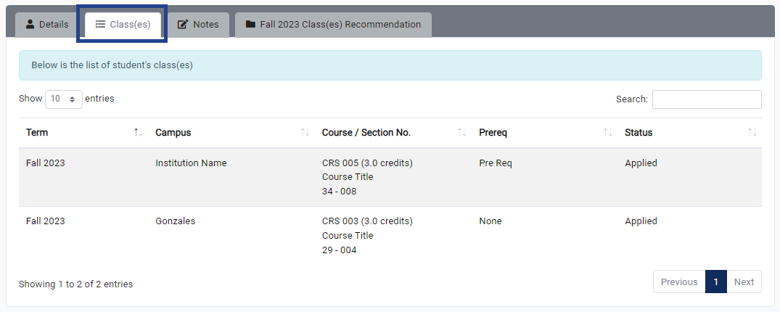
Other information available to you in this pop-up window include basic demographic and contact information for the student on the “Details” tab.
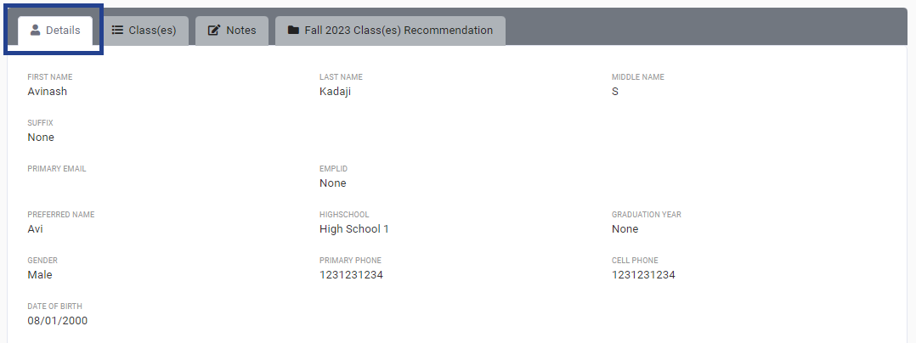
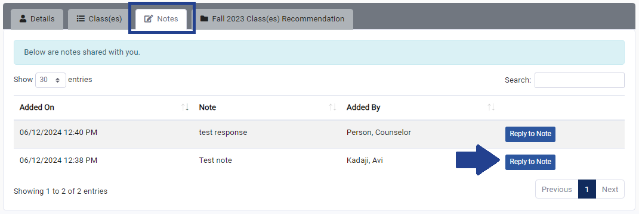
Additionally, any notes about the student that have been entered can be found on the “Notes” tab. If there are any notes available, you will have the opportunity to respond to them (if necessary).
When you are finished managing a student’s application, click the “X” in the bottom right corner of the pop-up window.

Registrations by Term
The “Registrations by Term” tab lists the students who have registered for classes each term by course. You can filter by the term in the right corner, or search for a specific student or course. In the Last Name column, you can also check whether the student has completed the Student Agreement and Parental Consent forms at a quick glance.
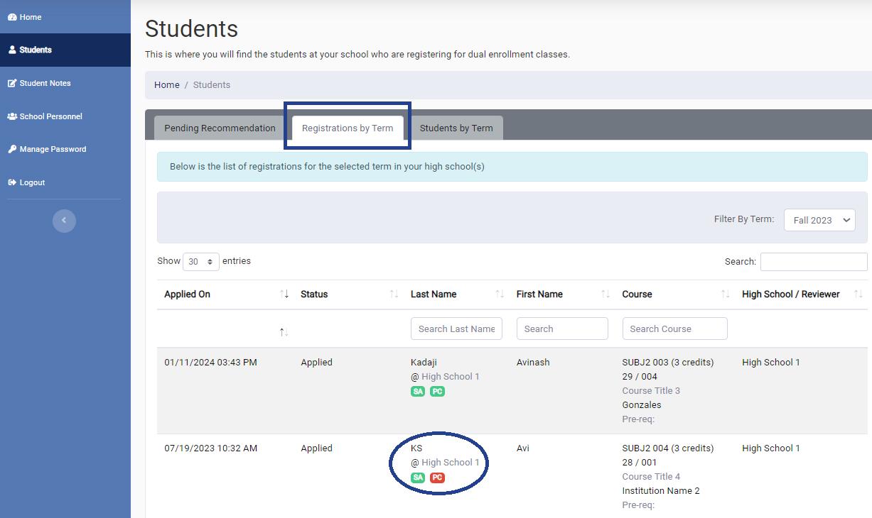

Students by Term
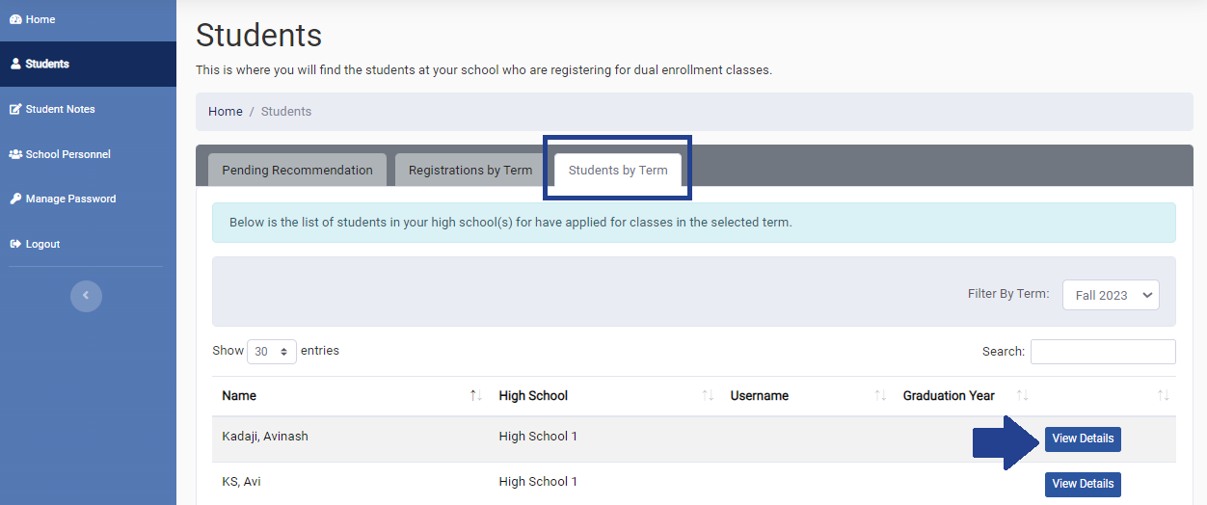
The “Students by Term” tab displays a listing of all students that have registered for classes for the selected term. To view more information about each student and their registrations, click the “View Details” button.

Part 2: Student Notes
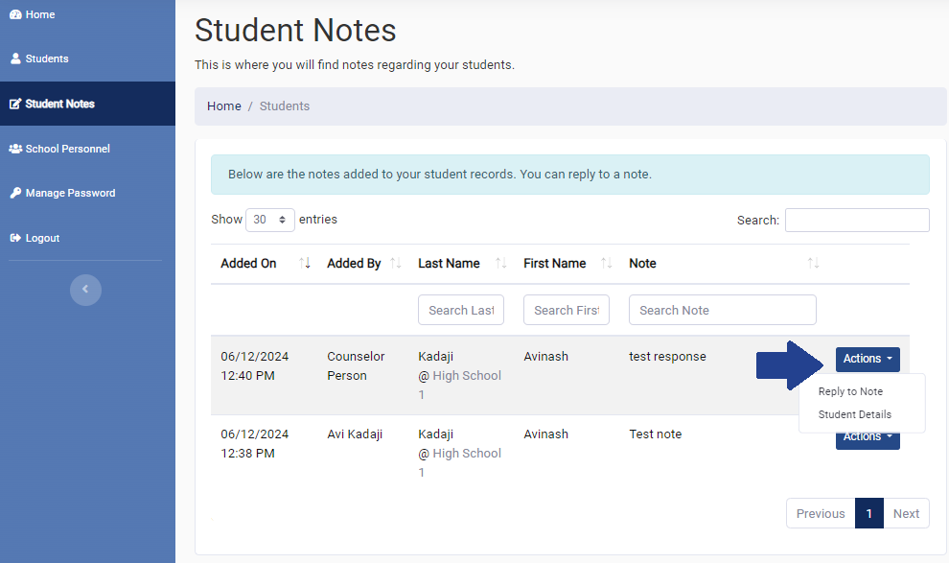
To quickly check if any notes have been added to a student record, click on the “Student Notes” tile on your home screen or tab in the left sidebar. This screen will display any notes that have been added and will allow you to reply to a note if needed.

Part 3: Managing School Personnel
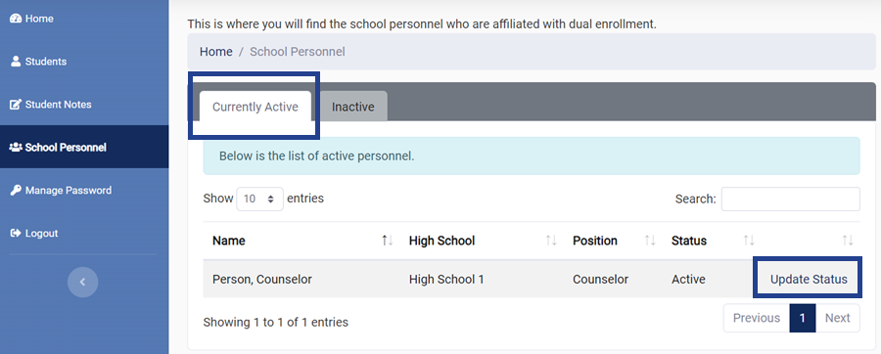
To manage your school’s personnel accounts, click on the “School Personnel” tile on your home screen or tab in the left sidebar. You can use the search bar in the right corner to find a specific person. Click on the “Update Status” link to update their account information.

A pop-up window will appear with options to update the person’s high school, position, status, effective date, whether they can manage student recommendations, and the option to enter any comments or notes. Please note that changing a person’s status from Active to Inactive will also disable their ability to manage student recommendations. When you’re finished, click “Save” at the bottom of the window.
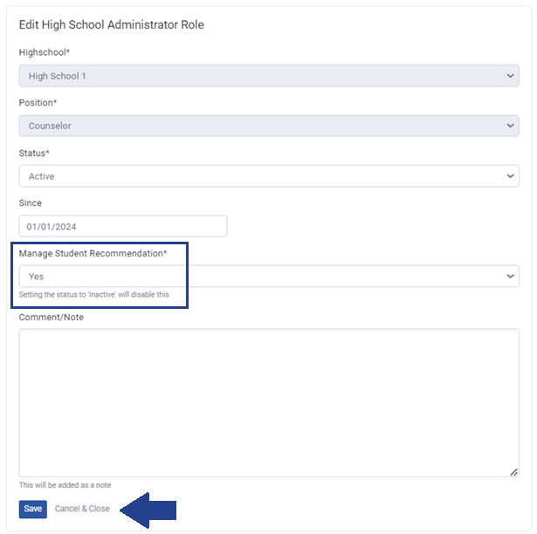
To access a list of Inactive personnel and update their status, go to the Inactive Personnel tab.
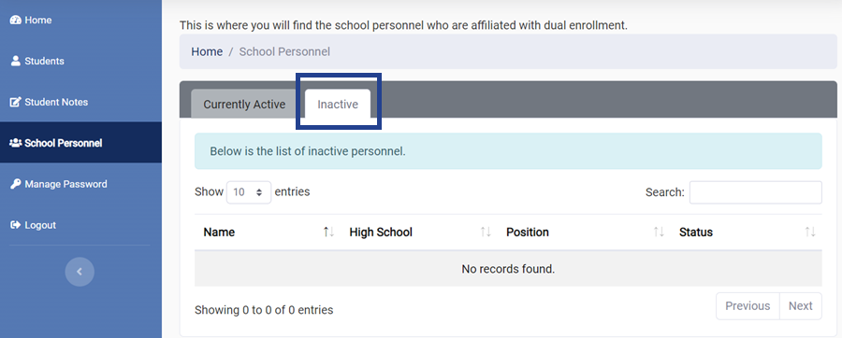

Part 4: Managing Your Password
To update your password, click on the “Manage Password” tile on your home screen or tab in the left sidebar. When choosing a new password, make sure to use a minimum of 8 characters.
