Apply DE Louisiana

Student Application

User Guide

Part 1: Submitting the Application Form 1
Part 2: Completing Your Application – Applying for Classes 5
Part 3: FERPA and Parental Consent 6
Part 4: My Profile 7
Part 5: Manage Password 8

Part 1: Submitting the Application Form
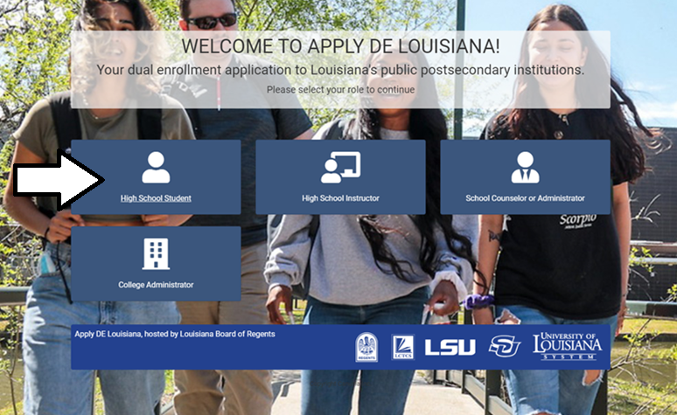
Welcome to Apply DE Louisiana – your dual enrollment portal to Louisiana’s public postsecondary institutions. To get started with your application, navigate to https://applyde.laregents.edu and select the “High School Student” tile.
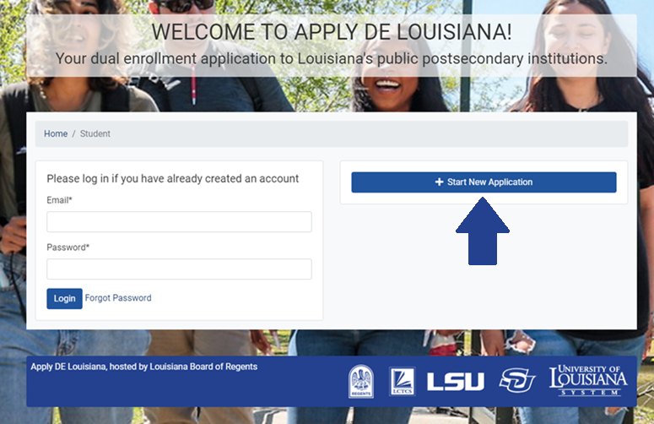
To begin, click on the “Start New Application” button. Once you’ve submitted your application and created your account, you’ll be able to log in through the left side of this screen.
Answer the questions throughout the application. Any required fields will be marked with an asterisk. Be sure to have your social security number on hand, as you will need to enter it to submit your application. A few key components are listed below, but be sure to answer as much as possible throughout the application.

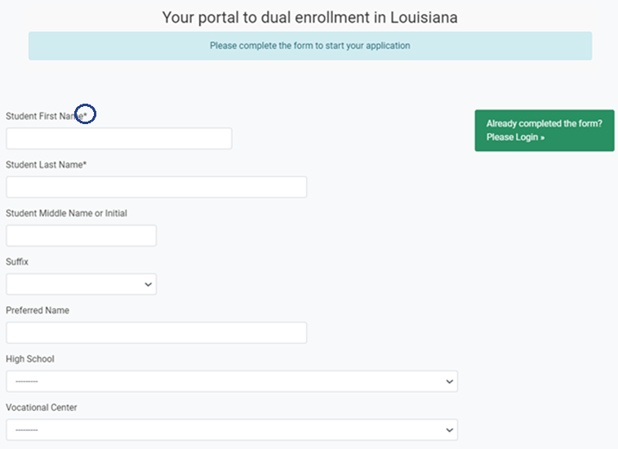
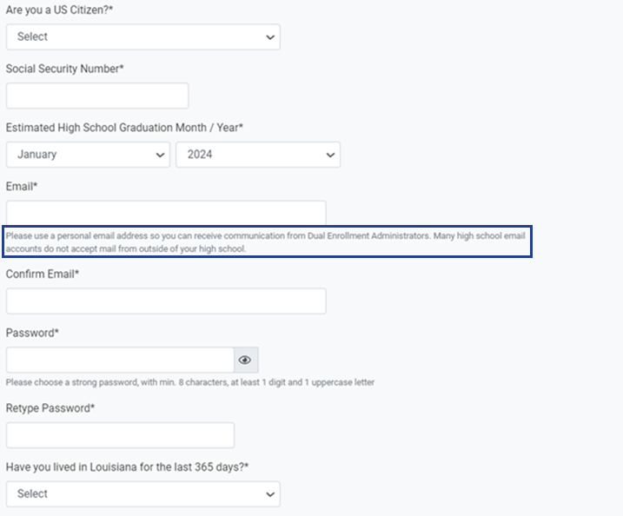
Please use a personal email address, like Gmail, so you can receive communications from Dual Enrollment Administrators. When creating a password, you’ll need to use a minimum of 8 characters, including at least 1 digit and 1 uppercase letter.
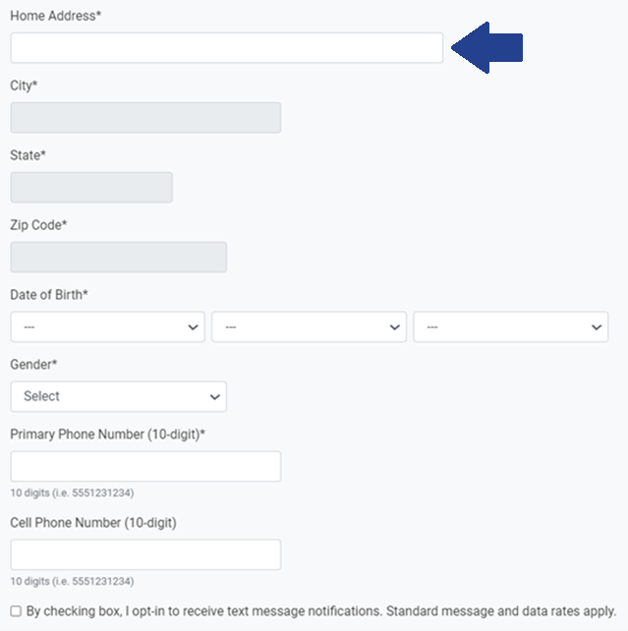
Start typing your home address into the home address field. When the correct address appears from the drop-down options, select it and it will auto-populate the remaining address fields for you. If your address does not display, continue typing it in manually. When entering your phone number, make sure to include the area code.
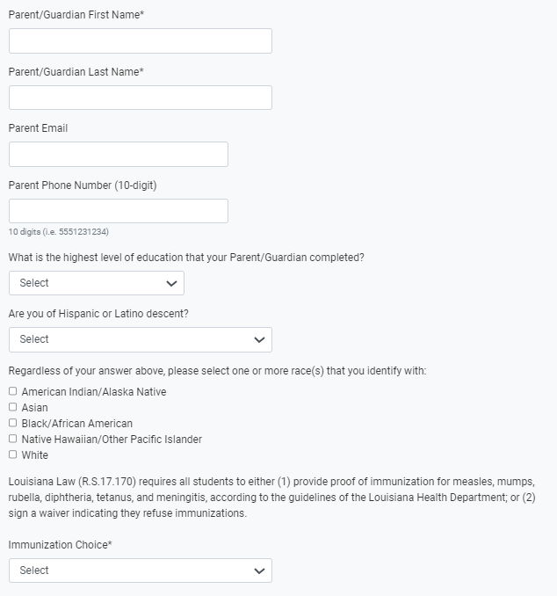
Select whether you will complete the immunization waiver or submit your immunization records.
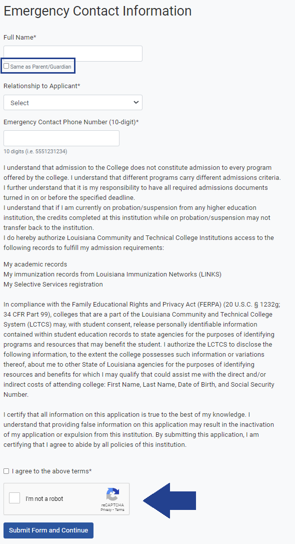
If you check the “Same as Parent/Guardian” box in the Emergency Contact Information section, the parent or guardian’s name you entered above will auto-populate as your Emergency Contact Information.

When you are finished, click that you agree to the terms listed, check the “I’m not a robot” box, and select the “Submit Form and Continue” button.

Part 2: Completing Your Application – Applying for Classes
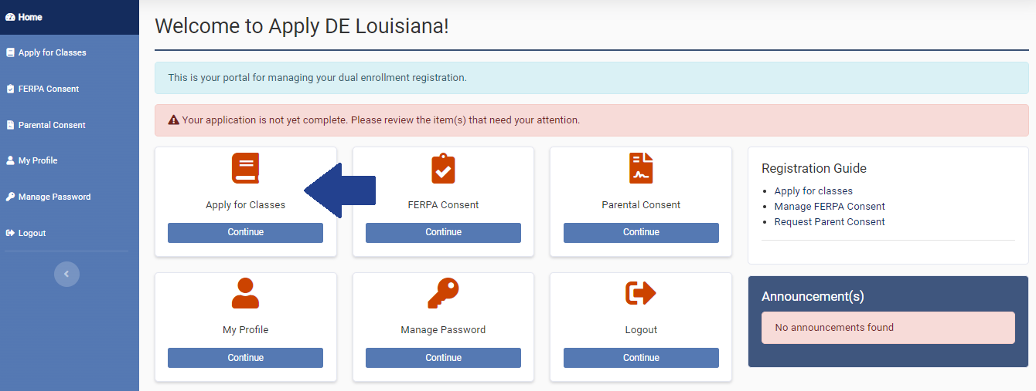
Now that you have submitted the first part of your application, it’s time to select classes to apply for. Click on the “Apply for Classes” tile on your home screen or tab in the left sidebar.

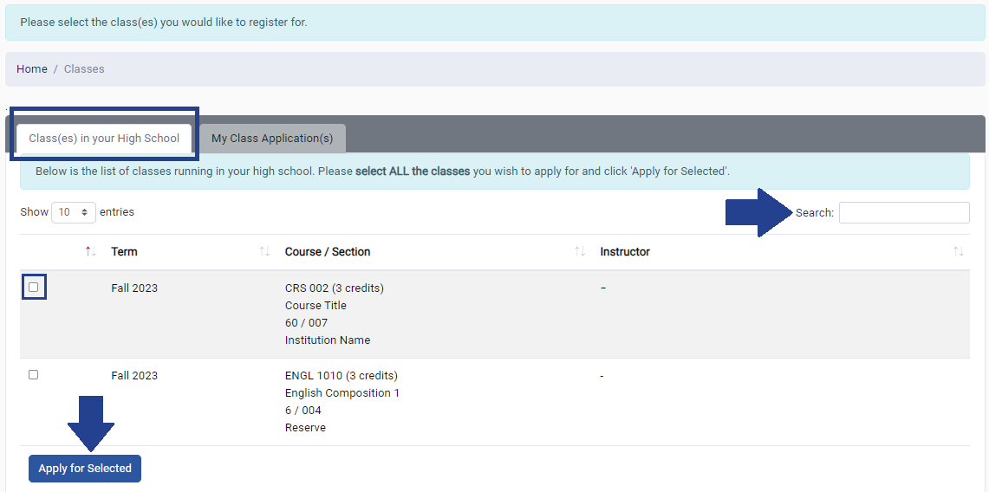
You’ll find some tabs to help you apply for classes. The “Class(es) in your High School” tab displays a list of all classes available through your high school. You can search for classes using keywords or course prefixes with the Search bar in the upper right corner. To apply for specific classes, select those checkboxes and click the “Apply for Selected” button. **Please note that you will be unable to apply for classes until you have signed the Student Agreement.

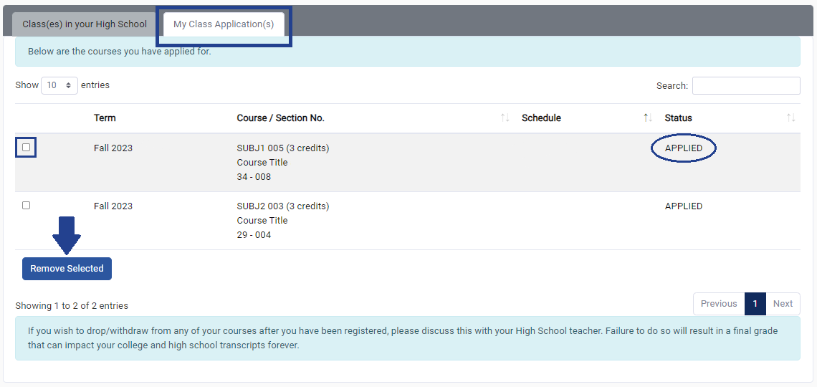
The “My Class Application(s)” tab lists the classes that you have applied for and their status. If you no longer wish to register for a class with a status of “Applied,” select the checkbox next to that course and click the “Remove Selected” button.

Part 3: FERPA and Parental Consent
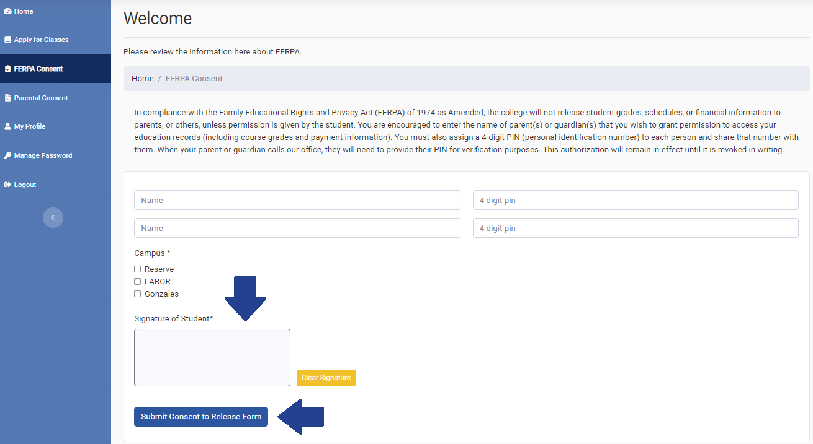
To review the optional FERPA Consent form, click on the “FERPA Consent” tile on your home screen or tab in the left sidebar. In compliance with the Family Educational Rights and Privacy Act (FERPA) of 1974 as Amended, the college will not release student grades, schedules, or financial information to parents, or others, unless permission is given by the student. If you wish to provide up to 4 parents or guardians with access to your education records (including course grades and payment information), you should enter their names on this screen and assign them a 4-digit PIN for verification purposes. When you are finished, provide your signature and click the “Submit Consent to Release Form” button.

Unlike the optional FERPA Consent form, the Parental Consent form is required in order to complete your application. You must first apply for classes before you can request Parental Consent. After entering your parent or guardian’s name and email, click the “Submit Parent Consent Request” button. Please be sure to remind your parent or guardian to check their email, including their Spam folder, and follow the instructions to complete the Parental Consent process.
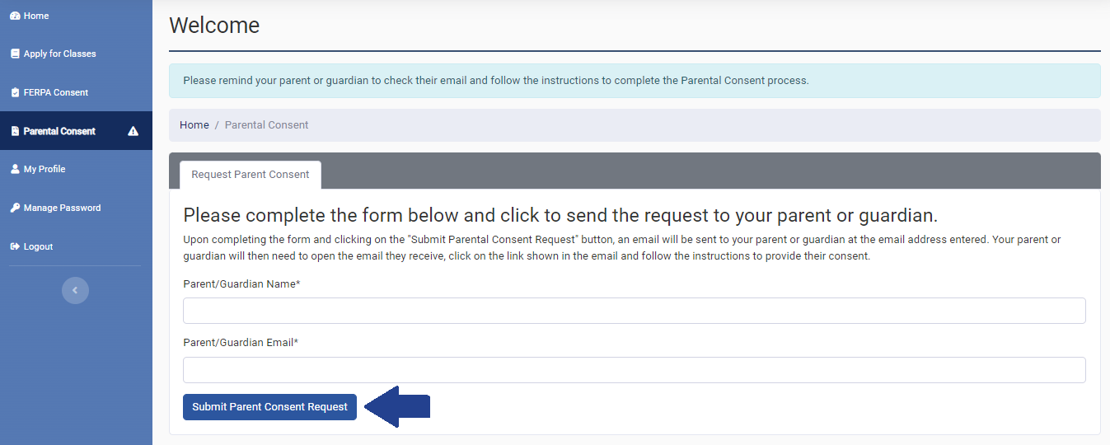

Part 4: My Profile
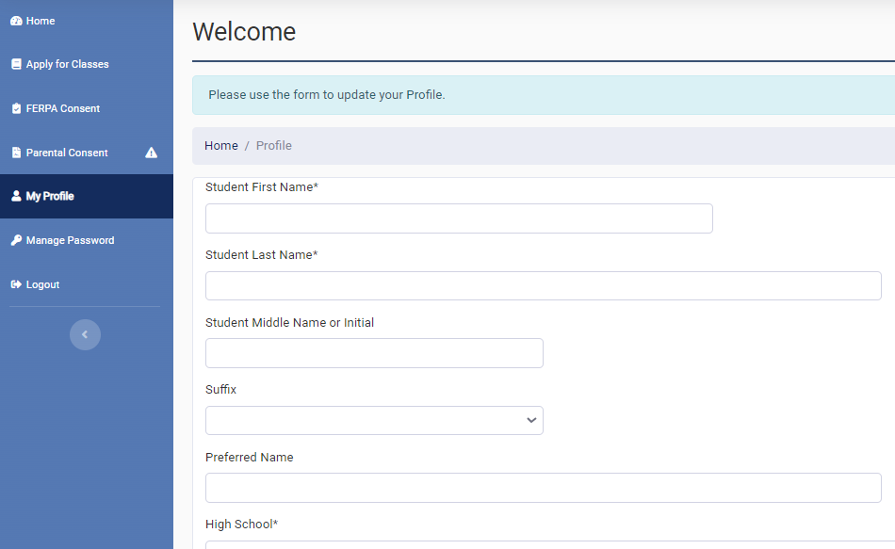
If you need to update any of the information from your original application, you can do so through the “My Profile” tile on your home screen or tab in the left sidebar. When you’re finished, click the “Update Profile” button at the bottom of the screen.

Part 5: Manage Password

If you need to update your password, you can do so through the “Manage Password” tile on your home screen or tab in the left sidebar. When you’re finished, click the “Update Password” button at the bottom of the screen.
